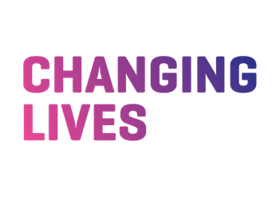
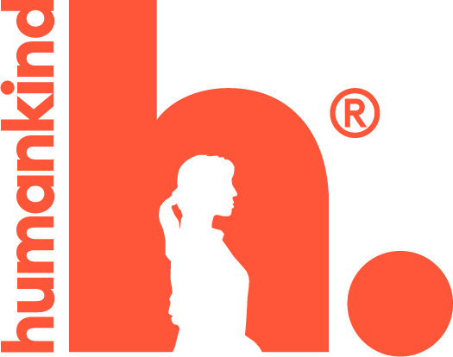

Complaints and Other Feedback Policy
Humankind, Spectrum Community Health,
& Changing Lives

Document Reference: | NYH12
Version: | V1.4
Name and role of author/s: | Sara Allen, Senior Quality & Performance Manager
Name and role of responsible person/policy owner: | Abigail Taylor, Quality & Performance Manager
Date issued: | November 2023
Review date: | November 2025
Target Audience | North Yorkshire Horizons Service Users, Stakeholders, Staff

Document Change Log
This document will be reviewed every 24 months or as changes in legislation and regulation dictate.
Version No | Date | Document Change
1.3 | Oct 2020 | Updated partner information.  Addition of 3.6.11 complaints made against staff members  Addition of Appendix 5 Key points for completing complaint investigation – moved from policy body.
1.3 | Oct 2022 | Two Yearly Review – No changes
1.4 | Aug 2023 | New Humankind Policy  NYH policy to reflect new policy but to be locailised and include partnership.

Introduction
North Yorkshire Horizons aims to provide services that fully meet the needs of our service users and stakeholders. North Yorkshire Horizons values Complaints and other feedback a as a vital tool for developing and improving our services. North Yorkshire Horizons receives a range of different feedback. We categorise this feedback as either a Complaint, Concern, Comment or Compliment.

North Yorkshire Horizons positive approach to complaints and concerns
North Yorkshire Horizons views complaints positively, as an opporunity to put things right if they go wrong, and improve our services. North Yorkshire Horizons will encourage and support people through the complaints process. North Yorkshire Horizons will ensure complainants are not discriminated against or victimised – the service a person receives will not be negatively affected if they make a complaint, or if somebody complains on their behalf.
North Yorkshire Horizons process for handling complaints and concerns aims to be fair, proportionate, clear, straightforward, and readily accessible to people who need to follow it. We recognise that people may feel vulnerable when making a complaint and that and the circumstances leading up to the complaint may be distressing or frustrating. We will ensure that complainants are treated with respect and empathy.

Key Points
- All feedback will be recorded on the HUB.
- Complaints can be made verbally or in writing, and the word ‘Complaint’ does not need to be used for it to be treated as such.
- Complaints can be made by anyone who is not a current employee of North Yorkshire Horizons if their concern meets the definition of this policy.
- An appropriate Complaint Handler will be appointed and they will be responsible for all communications with the complainant, investigating the complaint and ensuring any action needed to resolve the complaint is taken.

Scope
This policy relates to all activities of the North Yorkshire Horizons, Including partners.

Roles and responsibilities
- Complaint Handler is responsible for the investigation of the complaint, communication with the Complainant, and taking action to resolve the issues identified (where applicable).
- Operational Management Team will be responsible for ensuring that how to make a complaint is actively and appropriately promoted within their services, staff training is completed and learning from feedback is circulated and embedded.
- Quality and Performance Team is responsible for providing quarterly reports on complaints and other feedback, and regular service inspections to ensure our complaints procedure is accessible, the policy is followed and learning is used to improve our services.
- Spectrum Clinical lead will be notified of all complaints about the conduct of a Spectrum clinican and will act according to their own policies and procedures.
- The Integrated Clinical Governance Board (ICGB) will have strategic oversight of all complaints.

Promotion of the Complaints and Feedback Policy
North Yorkshire Horizons Complaints and Feedback Policy will be promoted to service users and other stakeholders, including within service user handbooks, reception areas and our websites. North Yorkshire Horizons will ensure that information will be made available in accessible formats and other languages on request.

Equality Statement
All customers, members of the workforce and members of the public should be treated fairly and with respect, regardless of age, disability, gender, pregnancy and maternity, marital or civil partnership status, membership or no membership of a trade union, race, religion or belief, domestic circumstances, sexual orientation, ethnic or national origin, social and employment status, HIV status, or gender re­assignment.

Links to Other Policies

Equality and Diversity
North Yorkshire Horizons positively promotes Equality and Diversity, delivering our services in line with the Equality Act 2010. Should complaints or concerns be received that indicate potential discrimination in relation to an individual’s protected characteristics, or other issue which suggests failure to meet the requirements of the Act, these will be handled formally in line with Humankind’s Equality and Diversity policies and with due regard to the Equality Act 2010.

Safeguarding
North Yorkshire Horizons works to effectively safeguard both adults and children. Should a complaint or concern indicate potential failings in relation to North Yorkshire Horizons safeguarding responsibilities, including allegations of abuse, these concerns will be handled formally and in line with North Yorkshire Horizons safeguarding policies and procedures. North Yorkshire Horizons will involve relevant external bodies as appropriate, including the Local Authority Designated Officer (LADO), CQC and the Police.

Data Protection
North Yorkshire Horizons will handle complaints and other feedback in line with the General Data Protection Regulations (GDPR) 2016, and Information Governance requirements including in relation to consent, confidentiality and the appropriate recording, management and sharing of information. North Yorkshire Horizons will notify the Information Commissioner’s Office (ICO) should a breach meeting the threshold for notification occur.

Duty of Candour
North Yorkshire Horizons will act in accordance with Regulation 20: Duty of Candour in respect of complaints about care and treatment that have resulted in a notifiable safety incident within North Yorkshire Horizons CQC registered delivery.

Definitions
- A Complaint is an expression of dissatisfaction, however made, about the standard of service, actions, or lack of action by the organisation, our staff, or those acting on our behalf.
- A Concern is an expression of dissatisfaction that is not handled through the formal complaints’ procedure.
- A Comment is feedback which is neutral i.e neither an expression of dissatisfaction or a positive statement. This might be an observation or suggestion for improvement where the person making the comment isn’t dissatisfied with the current service. Comments can be useful for informing service change and improvement.
- A Compliment is positive feedback about the service provided and is normally given without wanting to receive a response. Compliments are useful for identifying when things are working particularly well, often highlighting good practice. This can help inform service change and improvement and provide positive feedback to the individuals involved.
- Complainant is the person making the complaint. This may be a service user, third-party making the complaint on behalf of a service user, a representative of another organisation or a member of the public.
Appendix 1: Categorising Feedback and Appendix 2: Complaint, Concern, Comment or Compliment? provide additional guidance on how to catergorise and respond to different types of feedback.

Complaints and Concerns
A Complaint is an expression of dissatisfaction, however made, about the standard of service, actions, or lack of action by the organisation, our staff, or those acting on our behalf. Dissatisfaction is usually treated as a complaint if it:
- Cannot be resolved by the next working day
- Needs to be investigated to establish the facts, to allow the issue can be put right, or to identify learning
- Indicates a possible breach in North Yorkshire Horizons Code of Conduct by a staff member or volunteer
- Meets the definition of ‘serious complaint’
- Agreed by a line manager that is needs to be recorded and handled as a ‘complaint’

A Concern is an expression of dissatisfaction that is not handled through the formal complaints’ procedure as:
- It can be resolved, either immediately or within 1 working day to the satisfaction of the person raising the issue
- Has minimal impact on one or few individuals
- The person raising the issue not wishing to make a formal complaint
- It does not require formal investigation to establish facts
- The issue that doesn’t indicate a breach in North Yorkshire Horizons Code of Conduct, or definition of ‘serious complaint’
- Is agreed to be a ‘concern’ by line manager

Identifying Complaints and Concerns
The person does not need to use the word ‘complaint’ for it to be treated as such. We will use the language chosen by the person, or their representative, when they describe the issues they raise (for example, ‘issue’, ‘concern’, ‘complaint’, ‘tell you about’). We will always speak to people to understand the issues they raise and how they would like us to consider them.
Complaints do not need to be made in writing and can be made to any employee of volunteer by telephone, in person, by email, text, letter or via North Yorkshire Horizons websites and social media.

Complaints Received via Social Media and Online
Complaints can be received via the services’ email addresses published via our websites. These are forwarded on to the relevant service Manager/Director who will allocate a complaint handler, who will acknowledge the complaint and record it on the Hub.
Complaints posted to North Yorkshire Horizons social media will be immediately sent to the relevant service Manager and Director who will agree a response. It is the service’s responsibility to allocate a Complaint Handler and record the complaint on the Hub and acknowledge the complaint. If visible to the public on social media, a decision must be taken on whether to engage with the complaint publicly or not.
Feedback posted to websites or social media apps that are not managed by Humankind should be forwarded to Media & Comms who will liaise with the relevant service Manager and Director who will agree what action, if any to take

Who can make a complaint or raise a concern?
Dissatisfaction from people who do not work for North Yorkshire Horizons may be categorised as a complaint or concern if it meets the above criteria. This includes current and former service users, their families/friends or anyone else making a complaint on their behalf, staff from other organisations, MP/Councillor, or members of the public.
North Yorkshire Complaints Recording Form can be found in the Relevant Document section of this policy.

Feedback that is not a Complaint or Concern
It’s important that the most appropriate procedure is followed to address issues and provide the outcomes sought. The following are not considered to be a Complaint or Concern and an alternative policy should be followed. Appendix 1 contains further guidance on categorising feedback.
- An initial request for service, or change in service where this isn’t linked to the standard of service provided: for example, a request for a female worker rather than a male worker
- Asking for explanation of a policy or decision: for example, a service user requesting the reason why visits should be conducted by two members of staff, or why their prescription was changed.
- An appeal against a decision where an appeal process is in place in relation to that decision, for example, the Housing Allocations process and Education Assessment process both give people a right to appeal and explain how to request one.
- Expressions of dissatisfaction by North Yorkshire Horizons staff. These should be either formally or informally through the organisation’s Grievance procedures.
- Legitimate concerns from staff that are classed as ‘qualifying disclosures’ under the Disclosures in the Public Interest (Whistleblowing) Policy.
If a person explicitly states that they wish to make a complaint, but the complaint is not accepted on the above grounds, a clear and detailed response must be provided to the person.
The following may be categorised as complaints and should be considered on a case by case basis
- Expressions of dissatisfaction received from former North Yorkshire Horizons employees should be considered on a case by case basis in discussion with Human Resources, and may fall within the scope of this policy where the complaint doesn’t directly relate to that person’s employment.
- Complaints made by North Yorkshire Horizons Volunteers may be addressed using the Complaints Policy.
Additional guidance on categorising and dealing with feedback and concerns which do not meet the definition of a complaint or concern, is provided in Appendix 1: Categorising Feedback

Serious Complaints
A Serious Complaint is a complaint where the consequences to service users, the public, staff or North Yorkshire Horizons and / or partner organisations are so significant, or the potential for learning is so great, that a heightened level of response is justified. The list below is not intended to be exhaustive, however a serious complaint is likely to involve a complaint in relation to:
- Serious misconduct of North Yorkshire Horizons or partner staff member or volunteer, including allegations of such. (For example allegation of abuse against a member of staff).
- Significant or sustained negative media attention
- Reputational damage to North Yorkshire Horizons or partner agency
- Substantial disruption to service delivery, or operation of Humankind, or a partner organisation.
- Significant failing by North Yorkshire Horizons or partner organisation relation to safeguarding of adults or children (or where this is likely to be the case).
- A complaint relating to the serious injury or death of any person.
- A breach of Information Governance requiring notification to the Information Commissioner.
- A complaint involving an event requiring notification to the Charity Commission, or one which is Riddor Reportable.
Serious Complaints should be investigated as all other complaints, with the additional steps:
- The Operations Director should be made aware as soon as possible of complaints that may meet the above definition. It will likely be necessary to inform service commissioners or other stakeholders (including for example the CQC) in the event of a serious complaint.
- The HUB record should be updated to ‘Serious Complaint’.
- A senior manager should complete the investigation.

Support and Assistance to Complain
North Yorkshire Horizons will ensure that reasonable adjustments are made to accommodate an individual’s needs. Complainants will be offered support to complain. This may include encouragement to make their views known, or practical support like arranging interpretation or signing services.
Complaints from third parties acting on behalf of complainants will be accepted with the consent of the complainant, or where the service user cannot complain unaided and cannot give consent because they lack capacity within the meaning of the Mental Capacity Act 2005.
Service users will be provided with information about other local and national organisations who can support them to make a complaint. Humankind will make available information about how to raise concerns outside of the organisation, for example to the service commissioner or CQC where applicable.

Repeat and Vexatious Complaints
Repeat Complaints are repeated complaints about an issue that has already been investigated and where appeal has been exhausted.
Vexatious Complaints are complaints that are made without sufficient grounds and are intended to cause upset, annoyance or inconvience.
Repeat or vexacious complaints will not be progressed further, with the agreement of the Operations Director. Complainants will be signposted to alternative complaint options including the service Commissioner and Ombudsman where applicable.
Each complaint will be considered on its own merits. If a complaint is received that is slightly different from the original complaint, but about the same broad area of activity, a decision will be made on whether the issues are sufficiently different to justify being considered as a new complaint.
Repeat and vexatious complaints will be acknowledged and complainants informed that their complaint will not be progressed further.

Suspension of the Complaints Procedure
Service Directors may decide to suspend the complaint process in the event that:
- Other bodies are already investigating aspects of the complaint, for example the police, or local authority safeguarding teams, this may result in the procedure being suspended until those public bodies have completed their investigations.

Withdrawn Complaints and Disengagement
If a complainant wishes to withdraw their complaints, we will confirm this with them and respect their wishes to no longer participate in the complaint investigation. The complaint handler should agree with the Director, whether to complete or discontinue the investigation, as there may be concerns that the service feels need to be investigated.
It is sometimes the case that a Complainant will not engage with the process, beyond providing the initial feedback. The Complaint Handler should attempt to contact the Complainant and offer support to engage with the process; this should not cause the investigation to exceed 20 day timescale. If attempts to contact the Complainant are unsuccessful, consideration should be given to investigating the complaint as fully as possible, based on the available information.

Anonymous Complaints
North Yorkshire Horizons will record and investigate anonymous complaints and concerns to the degree that it is possible to do so.

Effective Complaint Handling Strategies
North Yorkshire Horizons recognises that when dissatisfied, people may feel upset, angry or frustrated, and there may be distressing circumstances leading up to a complaint. People may have had poor experiences with services in the past and/or be dealing with current issues which may impact on their behaviour or communication. North Yorkshire Horizons has a duty to ensure the safety of staff, service users and visitors to all services and so aggressive, abusive or discriminatory behaviour and unreasonable demands from complainants are not acceptable.
Behaviour should not be classed as unacceptable simply because a person is being assertive, determined and advocating for themselves.
Challenging situations can often be prevented by:
- Promoting a culture of being receptive to complaints
- Making it straightforward and easy to make a complaint/raise a concern
- Treating people with respect and using active listening to show we are taking their concerns seriously
- Keeping the complainant informed about the investigation
- Managing expectations
- Taking the time to explain our decisions about the complaint and how we reached them
Further guidance about effective complaint handling can be found in Appendix 6: Guidance for Complaint Handlers: Effective Complaint Handling Strategies. North Yorkshire Horizons Challenging Behaviour Policy may be followed to deal with unreasonable behaviour from a complainant who is a service user.

Complaints relating to more than one North Yorkshire Horizons Team/Partner
If the concerns relate to more than one North Yorkshire Horizons team, one Complaint Handler should be appointed to to investigate all of the concerns and act as a single point of contact for the Complainant. The Complaint Handler will liaise with the relevant teams and provide a coordinated response to reduce frustration and confusion for the Complainant.

Complaints involving Multiple Organisations
When reviewing complaints which include issues relating to other organisations, Complaint Handlers should clarify with the complainant, which of the key points relates to North Yorkshire Horizons. The complainant should be supported to raise other concerns with the relevant organisation.

Complaint Handling Procedures
Flow charts outlining the complaint handling and appeal procedures are in Appendices 3 and 4.

Complaint Handling: Informal Resolution to Concerns
Our staff speak to people who use our service every day. This can often raise issues that our staff can help with immediately. We encourage people to discuss any issues they have, as informal resolution can offer a fast and effective resolution to dissatisfaction. Complaints can be resolved informally, if they meet the definition of a Concern.
All employees are able to resolve low level complaints, or concerns -
- Thank the person for bringing the matter to our attention, and ask what they would like to happen to resolve the concern
- If it seems likely the issue can be handled informally as a concern, speak to line management and confirm this course of action
- Attempt to resolve the issue immediately to the complainant’s satisfaction. Where this isn’t possible there and then, inform the complainant when action will be taken, or that the concern will be considered in ongoing review of the service, as appropriate.
- Record as a Concern on the HUB. Hub – Complaints, Concerns, Comments and Compliments – User Guide is on Cascade in this policy’s folder
- North Yorkshire Horizons, partner organisation should also record on their own internal reporting system (Changing Lives – Datixx, Spectrum – Ulysses).
The process of appeal does not apply to complaints handled informally. Dissatisfaction with informal resolution should prompt consideration of handling the complaint formally.

Complaint Handling: Formal Resolution
North Yorkshire Horizons will aim to resolve all complaints within 20 working days of receipt. Where this is not possible, for example if the complaint relates to more than one team or is complex and requires a longer investigation, we will explain to the complainant and agree a revised timescale.

Responsibility
The Complaint Handler is responsible for the investigation of the complaint, communication with the Complainant, and taking action to resolve the issues identified (where applicable). The Complaint Handler should be a Manager, who has completed North Yorkshire Horizons e-learning, with sufficient authority to put the issues identified right, should the complaint be upheld. Where a complaint is categorised as ‘serious’, a senior manager should be appointed as the Complaint Handler. The Complaint Handler cannot be a person the complaint relates to.
Complaint handlers will:
- deal with complaints on their merits
- act independently and have an open mind
- take measures to address any actual or perceived conflict of interest
- consider all information and evidence carefully
- keep the complaint confidential as far as possible, with information only disclosed if necessary to properly investigate the matter
- consider the complaint in relation to relevant organisational policy, regulations, published guidance, and occupany agreement.
Appendix 5: Complaint Handler Checklist is a useful reference document to support the complaint handling process. Appendix 6 has additional guidance for Complaint Handlers on effective complaint handling strategies.

Timescales
All complaints will be acknowledged in writing within 3 working days. A template letter for acknowledging the receipt of a complaint can be found in the ‘Relevant Document’ section of this policy. Template letters may need to be amended to suit the needs of the complaint/complainant.

Investigation
The goal of investigation is to establish the facts and decide whether the service provided has fallen below the level that could be reasonably expected. The complaint handler should seek to establish:
- What happened
- What should have happened
- The cause of any identified failings
- What can be done to put right any failings

Investigation should proceed as follows:
- Speak with the complainant to establish the full details of the complaint and record this on the HUB. Hub – Complaints, Concerns, Comments and Compliments – User Guide is on Cascade in this policy’s folder.
- This could be via phone or in person (preferably in person, if the complainant agrees). Make sure you:
- Thank the complainant for bringing the issue to North Yorkshire Horizons attention and assure them that the service they receive will not be negatively affected by letting us know about this issue.
- Identify if the person needs additional support through the complaints process. The complainant’s needs around translation, interpretation or disability should be considered, and action taken to enable the complainant to effectively complain.
- Ask the complainant to state in their own words their complaint. Where the complainant has made their complaint in writing, each point within the complaint should be clarified, with more detail requested if necessary. Record key dates, times and events. Use open questions to gain as full a picture as possible of the events relating to the complaint.
- Listen carefully. Confirm the complainant’s concerns and the issues to be investigated. Support the individual to pin-point the specifics of their complaint. This is important as complaints can sometimes contain a number of issues. Being specific about the key points of the complaint allows each aspect to be investigated, and a decision made as to whether the complaint is Upheld, Partially Upheld or Not Upheld.
- Ask what resolution the complainant would like to see. If appropriate, manage expectations and explain what is possible.
- Read back a summary of the complaint to the complainant.
- Agree how to keep the complainant updated and involved, and how often.
- Explain what will happen next, including the evidence you plan to review and how long the proess is likely to take. Be open and realistic.
- If the complaint was made in person, or over the phone, provide a written summary of the complaint to the complainant.
- It is sometimes the case that a complainant will not engage with the process, beyond providing the initial feedback. Attempt to contact the complainant and offer support to engage with the process; this should not cause the investigation to exceed 20 day timescale or 10 day timescale in the case of Housing complaints. If attempts to contact the complainant are unsuccessful, consideration should be given to investigating the complaint as fully as possible, based on the available information.
- Speak to witnesses or others who could help establish the facts.
- Where the complaint relates to conduct of North Yorkshire Horizons or partner organisation staff, speak to the relevant staff member(s).
- Review any other information, such as written information, records on management information systems, or CCTV footage.
- Record the investigation on the HUB.

Where complainants raise additional complaints during the investigation, these should be incorporated into the investigation if they are relevant and the outcome to the investigation has not been issued. Where the outcome of the investigation has been issued, or it would unreasonably delay the response, the complaint should be logged as a new complaint. This should be very clearly communicated to the complainant.
During investigation consider consent, confidentiality, Data Protection and Information Governance. Remember that other parties will have varying knowledge of the circumstances surrounding the complaint and that there should be no inappropriate disclosure of such information to other parties.

Complaints Relating to the Conduct of a Humankind Staff Member
Most complaints about the conduct of a staff member can be investigated and resolved using the complaints process. However, the Complaint Handler/Line Manager should contact a People Team Business Partner/Advisor before the complaint investigation starts, if
- the complaint is categorised as serious due to the alleged conduct of a staff member, or
- the complaint indicates behaviour which meets Humankind’s definition of Gross Misconduct
Gross misconduct refers to any serious breach of Company Policy, procedure, terms and conditions of employment or Code of Conduct. Examples of Gross Misconduct are listed in the Disciplinary Policy.
If during the investigation concerns about staff gross misconduct arise, these should be discussed with the People Team Business Partner/Advisor, without delay.
Where it is deemed appropriate for a disciplinary investigation to be completed, the Complaint Handler, Service Director and Business Partner will agree if that will take place:
- at the same time as the complaint investigation. If key points of the complaint relate to the service and can be investigated by the Complaint Handler, but points relating to the conduct of a staff member need to be investigated under the disciplinary process.
- following the conclusion of the complaint investigation. Where the complaint is straight forward and does not include allegations of gross misconduct.
- by pausing the complaint investigation. This may be necessary for serious complaints involving gross misconduct. The complainant should be kept informed if this means their complaint cannot be resolved within the complaint policy timescales.
In the event of a disciplinary investigation being opened:
- an Investigation Manager will be identified and appointed to carry this out, This should be a different manager to the Complaint Handler.
- the Complaint Handler remains responsible for the complaint process, including keeping the complainant up to date and informing them of the outcome of their complaint.
- feedback about the complaint outcome and any action taken must be agreed with the People Team before it is communicated to the complainant, to maintain the privacy of staff.
- Investigation may indicate it is necessary to notify external bodies for example the Care Quality Commission, Commissioners, the Police or local safeguarding boards. This will be discussed with the service Director and responsibility for making notifications agreed. Notifications will not be made by the People Team.
- Compliants relating to the conduct of Spectrum or Changing Lives staff members will be investigated using their services processes and policeis.

Support to Staff Members Who the Complaint Relates to
Regardless of whether the disciplinary process is followed, North Yorkshire Horizons recognises the impact on staff of being named in a complaint. Line managers should ensure that staff are supported and engaged in the complaints process, including the learning that can be gained.

Complaints Relating to Data Protection: Data Controller and Data Processor Accountability
In the case of complaints that have a data protection element (such as an alleged breach or infringement of the data protection act) and where North Yorkshire Horizons is the Data Processor, the project must notify the Data Controller organisation of the complaint without undue delay and the outcome of investigation must be updated to the Controller. The outcome letter should also be signed off by the Controller as any negative repercussions could create a high risk for the Controller who is ultimately legally responsible for protecting the data and complying with the Data Protection Act.

Deciding the Outcome
The conclusion reached must be based on objective review of evidence. An outcome for each of the key points should be determined; which will inform the overall outcome of the complaint. Following investigation, a complaint may be found to be Upheld, Partially Upheld or not Upheld.
A Complaint is upheld when it is concluded that the service provided which led to the complaint fell below the standard that could be reasonably expected, in relation to all points of the complaint.

A Complaint is Partially Upheld when it is concluded that the service provided that led to the complaint fell below the standard that could reasonably be expected, in relation to some points of the complaint but not others.
A Complaint is Not Upheld when it is concluded that the service provided did not fall below the standard that could reasonably be expected in relation to all points of the complaint.

Communicating the Outcome

Communication to the Complainant
The outcome of the complaint should be communicated to the complainant at first verbally. This gives the complaint handler the opportunity to answer any questions the complainant may have or give clarity if needed. This should help reduce the likelihood of the complainant being dissatisfied with the outcome of the complaint.
The decision/outcome should then be confirmed in writing to the complainant. Complainants should be made aware of their right to appeal the outcome and provided details of how to do this and the timescales for doing so.
When preparing to share the outcome with the complainant, consider, is this as good a response as you would like to receive yourself. Your response should:
Be clear and compassionate
- Include all key points that were agreed with the complainant at the start of the investigation.
- Use language that is empathetic and that the complainant can understand.
Provide evidence
- Set out how you have investigated the complaint and what evidence you considered, for example interviews with relevant staff, departmental and clinical records.
Explain whether or not the service provided fell below the standard that could be reasonably expected:
- What happened, with reference to the evidence
- What should have happened, quoting relevant regulations, standards, policies or published guidance, and if they were met. In the case of Housing complaints, referencing any relevant legal obligations.
- If there is a difference between what happened and what should have happened, explain what this is and the impact it has had.
Be clear about your decision and any action you will take
If you found that the service provided fell below the standard that could be reasonably expected; include:
- a suitable apology
- an offer to put things right
- explanations of what lessons have been learnt
- details of how the organisation will put matters right for other service users
- where possible, offer to involve the complainant in the changes that take place as a result of their complaint.
Action they can take if not satisfied
- Clear information about how to request an appeal
- Details of the relevant ombudsman, where applicable. A list of Ombudsman and their contact details is contained in Appendix 7.
A template letter for the outcome of a complaint can be found in the ‘Relevant Document’ section of this policy. Template letters may need to be amended to suit the needs of the complaint/complainant.

Communication to other people
Depending on the nature of the complaint and how it was received, it may be necessary to communicate the outcome with others, which may include:
- Staff members who the complaint relates to, and their line managers.
- A commissioner, if they were the original receipiant of the complaint

Redress (Putting things right)
Redress can take a number of forms. North Yorkshire Horizons should always consider the complainant’s wishes and try to meet these where possible or, where this is not appropriate, providing a full explanation of North Yorkshire Horizons position.
There are limits to North Yorkshire Horizons ability to provide certain remedies, and complainant’s wishes may not always be reasonable. Any failings should be acknowledged and remedied quickly and fairly and in a way that best reflects the extent of the problems encountered by the complainant. Appropriate redress should include an apology, an explanation and correcting the error.
Generally, where service failings have been identified which have disadvantaged the client, attempts should be made to put the complainant back in the position they were in before the error occurred.
North Yorkshire Horizons management should look to improve procedures or systems or deliver further staff training to address service failures highlighted by the complaint where this is appropriate. The complainant should be told about action taken, but not details that affect individual staff members.

Appeals
If a complainant is unhappy with the response to their complaints, they can request that it is escalated to an appeal.
North Yorkshire Horizons Appeal Form can be found in the ‘Relevant Document’ section of this policy.

Timescales
The complainant can appeal the outcome of a complaint within 10 working days of receiving notification of the decision. The appeals process, and communication to the complainant should be completed within 10 working days.

Appeal Investigation
The purpose of the appeal is to address the specific grounds put forward by the complainant and not to repeat the complaint investigation. An Appeal Handler, who will be a different manager to Complaint Handler, will review the original complaint process, evidence considered and any additional information and determine if the original outcome was reasonable.
Flow charts outlining the complaint and appeal handling procedures are in Appendices 3 and 4.

Grounds for Appeal
The original investigation should be thorough and objective. A request for an appeal may be based on one of the following grounds:
- concern that the complaint was some weakness in the way the original investigation was completed (reasons for this should be stated in the appeal)
- new information relating to the original complaint that should be investigated
However, if these grounds are not met, this should not be a barrier to considering an appeal. Where a complainant remains dissatisfied with the outcome, North Yorkshire Horizons will take the opportunity to consider the decision.

Responsibility
An Appeal Handler should be appointed as soon as an appeal is request. The appeal handler will determine if the appeal grounds are met. The appeal handler should be a person more senior to the person who investigated the original complaint and should be senior enough to resolve the issues highlighted within the complaint and appeal. The Appeal Handler is responsible for investigating the appeal, communicating the outcome and putting in place actions to resolve the issues identified, where appropriate.

Communicating the Appeal Outcome
When communicating the outcome, the Appeal Handler should consider the guidance above about communicating the outcome. This should include:
- their decision about whether the complaint or aspects of it have now been upheld,
- what action will be taken, if applicable
- details of alternative complaint options if they remain dissatisfied such as a service commissioner or Ombudsman. A list of Ombudsman and their contact details is contained in Appendix 7.
A template letter for the outcome of an appeal can be found in the ‘Relevant Document’ section of this policy. . Template letters may need to be amended to suit the needs of the complaint/complainant.
Complaints can only be appealed once. This is the final stage of North Yorkshires Complaint Process before the complaint is closed.

Comments and Compliments
Comments are neutral feedback, i.e neither positive or negative. This might be an observation or suggestion for improvement where the person making the comment isn’t dissatisfied with the current service. Comments can be useful for informing service change and improvement.
Compliments are positive feedback about the service received. Compliments are useful for identifying when things are working particularly well, often highlighting good practice. This can help inform service change and improvement and provide positive feedback to the individuals involved.

Responsibility
Comments and Compliments can be handled by the person receiving the feedback

Recording
They should be recorded on the HUB under ‘Concerns, Comments and Compliments’. When recording concerns, the action taken in response should also be recorded.

Review
Comments and compliments should be reviewed regularly by management to enable trends and learning to be identified.

Promoting a Learning Culture

Training
All employees and volunteers will complete e-learning in identifying and responding to complaints, concerns and other feedback in line with the requirements of their role.
All managers will complete complaint handling e-learning before they act as a Complaint Handler.

Recording
Complaints, Concerns, Comments and Compliments will be recorded on the HUB Management Information System. This allows us to:
- report on the number and type of feedback being received
- identify trends
- drive improvement in service delivery
Recording will be in line with the GDPR 2018 and Humankind’s Data Management and Information Governance Policies. User guide for recording feedback, can be found on the HUB in the help menu.
North Yorkshire Horizons, partner organisation should also record on their own internal reporting systems (Changing Lives – Datixx, Spectrum – Ulysses).

Governance, Monitoring and Review
Complaints, Concerns, Comments and Compliments will be monitored and reviewed through North Yorkshire Horizons Quality and Performance manage.
Humankind’s Quality and Performance Manager will:
- provide quarterly reports on the number and type of complaints, outcomes, and trends
- prepare Learning Loops to promote identified learning from complaints and changes to practice that are needed
- monitor compliance with this policy through regular service inspections
North Yorkshire Horizons will review complaints and other feedback quarterly within integrated governance or management meetings where applicable. This review should include consideration of trends and learning.
North Yorkshire Horizons will provide service commissioners and regulatory bodies with appropriate information in relation to complaints received, in line with the requirements of that body. In relation to the CQC, North Yorkshire Horizons will provide within 28 days of request a summary of complaints received, North Yorkshire Horizons Response, correspondence and other relevant information.

Appendices
Appendix 1: Categorising Feedback
Appendix 2: Complaint, Concern, Comment or Compliment?
Appendix 3: Complaints and Appeal Handling Process – Simplified
Appendix 4: Complaints and Appeal Handling Process
Appendix 5: Complaint Handler Checklist
Appendix 6: Guidance for Complaint Handlers: Effective Complaint Handling Strategies
Appendix 7: Ombudsman and Alternative Complaint Options

Relevant Policies & Guidance
This policy should be read in conjuction with each partners organistaional complaints policy.
- Integrated Governance Policy
- Equality, Diversity and Inclusion Policy
- Mental Capactiy Act Policy
- Privacy and Personal Data Protection Policy
- Disciplinary Policy
- Volunteering Policy
- Challenging Behaviour Policy
- Quality Assurance Framework for Humankind’s Responsible Officer
- Social Media Policy and Guidance
- Media Policy

Relevant Documents
- North Yorkshire Horizons: Receipt of complaint Letter Template
- North Yorkshire Horizons: Complaints Outcome Letter Template
- North Yorkshire Horizons: Appeal Letters – 2 x Template
- North Yorkshire Horizons: Complaints Form
- North Yorkshire Horizons: Appeal Form

Appendix 1: Categorising Feedback
Type of feedback | Who received from | Process to follow
Dissatisfaction about the standard of service, actions or lack of action by the organisation, our staff or those acting on our behalf.  This could include:  - The conduct of staff, volunteers, contractors  - The way a person was spoken to  - Lack of support  - North Yorkshire Horizons processes not being followed  - A decision that was made about a person’s support/treatment (where there is not a separate appeal process in place) | - Current and former service users  - Family/friends of service users  - Staff from other organisations  - Member of the public  - Commissioner  - MP/Councillor | This is a concern or a complaint  Refer to the Complaints and Other Feedback Policy and Guidance to categorise and resolve
 | - Current employees | This is not a complaint  Grievance Policy and Guidance  Consult with HR
 | - Former employees | This may be a complaint and should be decided on a case-by-case basis, in consultation with HR  If the dissatisfaction directly relates to person’s employment, the Grievance Process should be followed. Otherwise, the Complaints process may be followed.
 | - Current or former volunteer | Volunteer Problem Solving Procedure should be followed. If not resolved, the Complaints policy should be followed in consultation with the Volunteer Development Manager.
Dissatisfaction with a decision – if there is a separate appeal process in place for that decision.  Eg The Housing Allocations process and Education Assessment process both give people a right to appeal. The relevant policies, explain how to request an appeal. | - Current and former service users  - Family/friends of service users  - Staff from other organisations  - Member of the public  - Commissioner  - MP/Councillor | Follow the relevant service appeals process
Dissatisfaction about the behaviour of a North Yorkshire Horizons resident/Tenant such as excessive noise, intimidation of neighbours, rubbish etc | - Neighbour  - Member of the public  - MP/Councillor  - Other Humankind Residents/Tenants  - Staff from other organisations | This is not a complaint  Follow the Anti-Social Behaviour Policy and Guidance and service processes
Dissatisfaction about how the service has dealt with/responded reports of anti-social behaviour of North Yorkshire Horizons Residents/Tenants | - Neighbour  - Member of the public  - MP/Councillor  - Other Humankind Residents/Tenants | This is a complaint  Follow the Complaints and Other Feedback Policy and Guidance

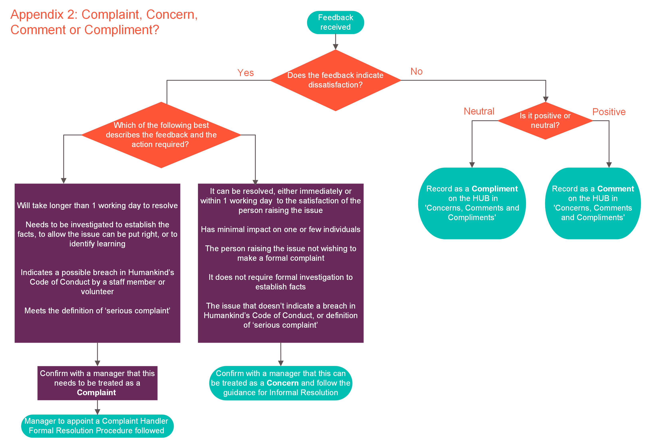
Appendix 2: Complaint, Concern, Comment or Compliment

** North Yorkshire Horizons Partners, Changing Lives and Spectrum to ensure recorded on their own internal reporting systems (Changing Lives – Datixx, Spectrum – Ulysses).

Appendix 3: Complaints and Appeal Handling Process – Simplified
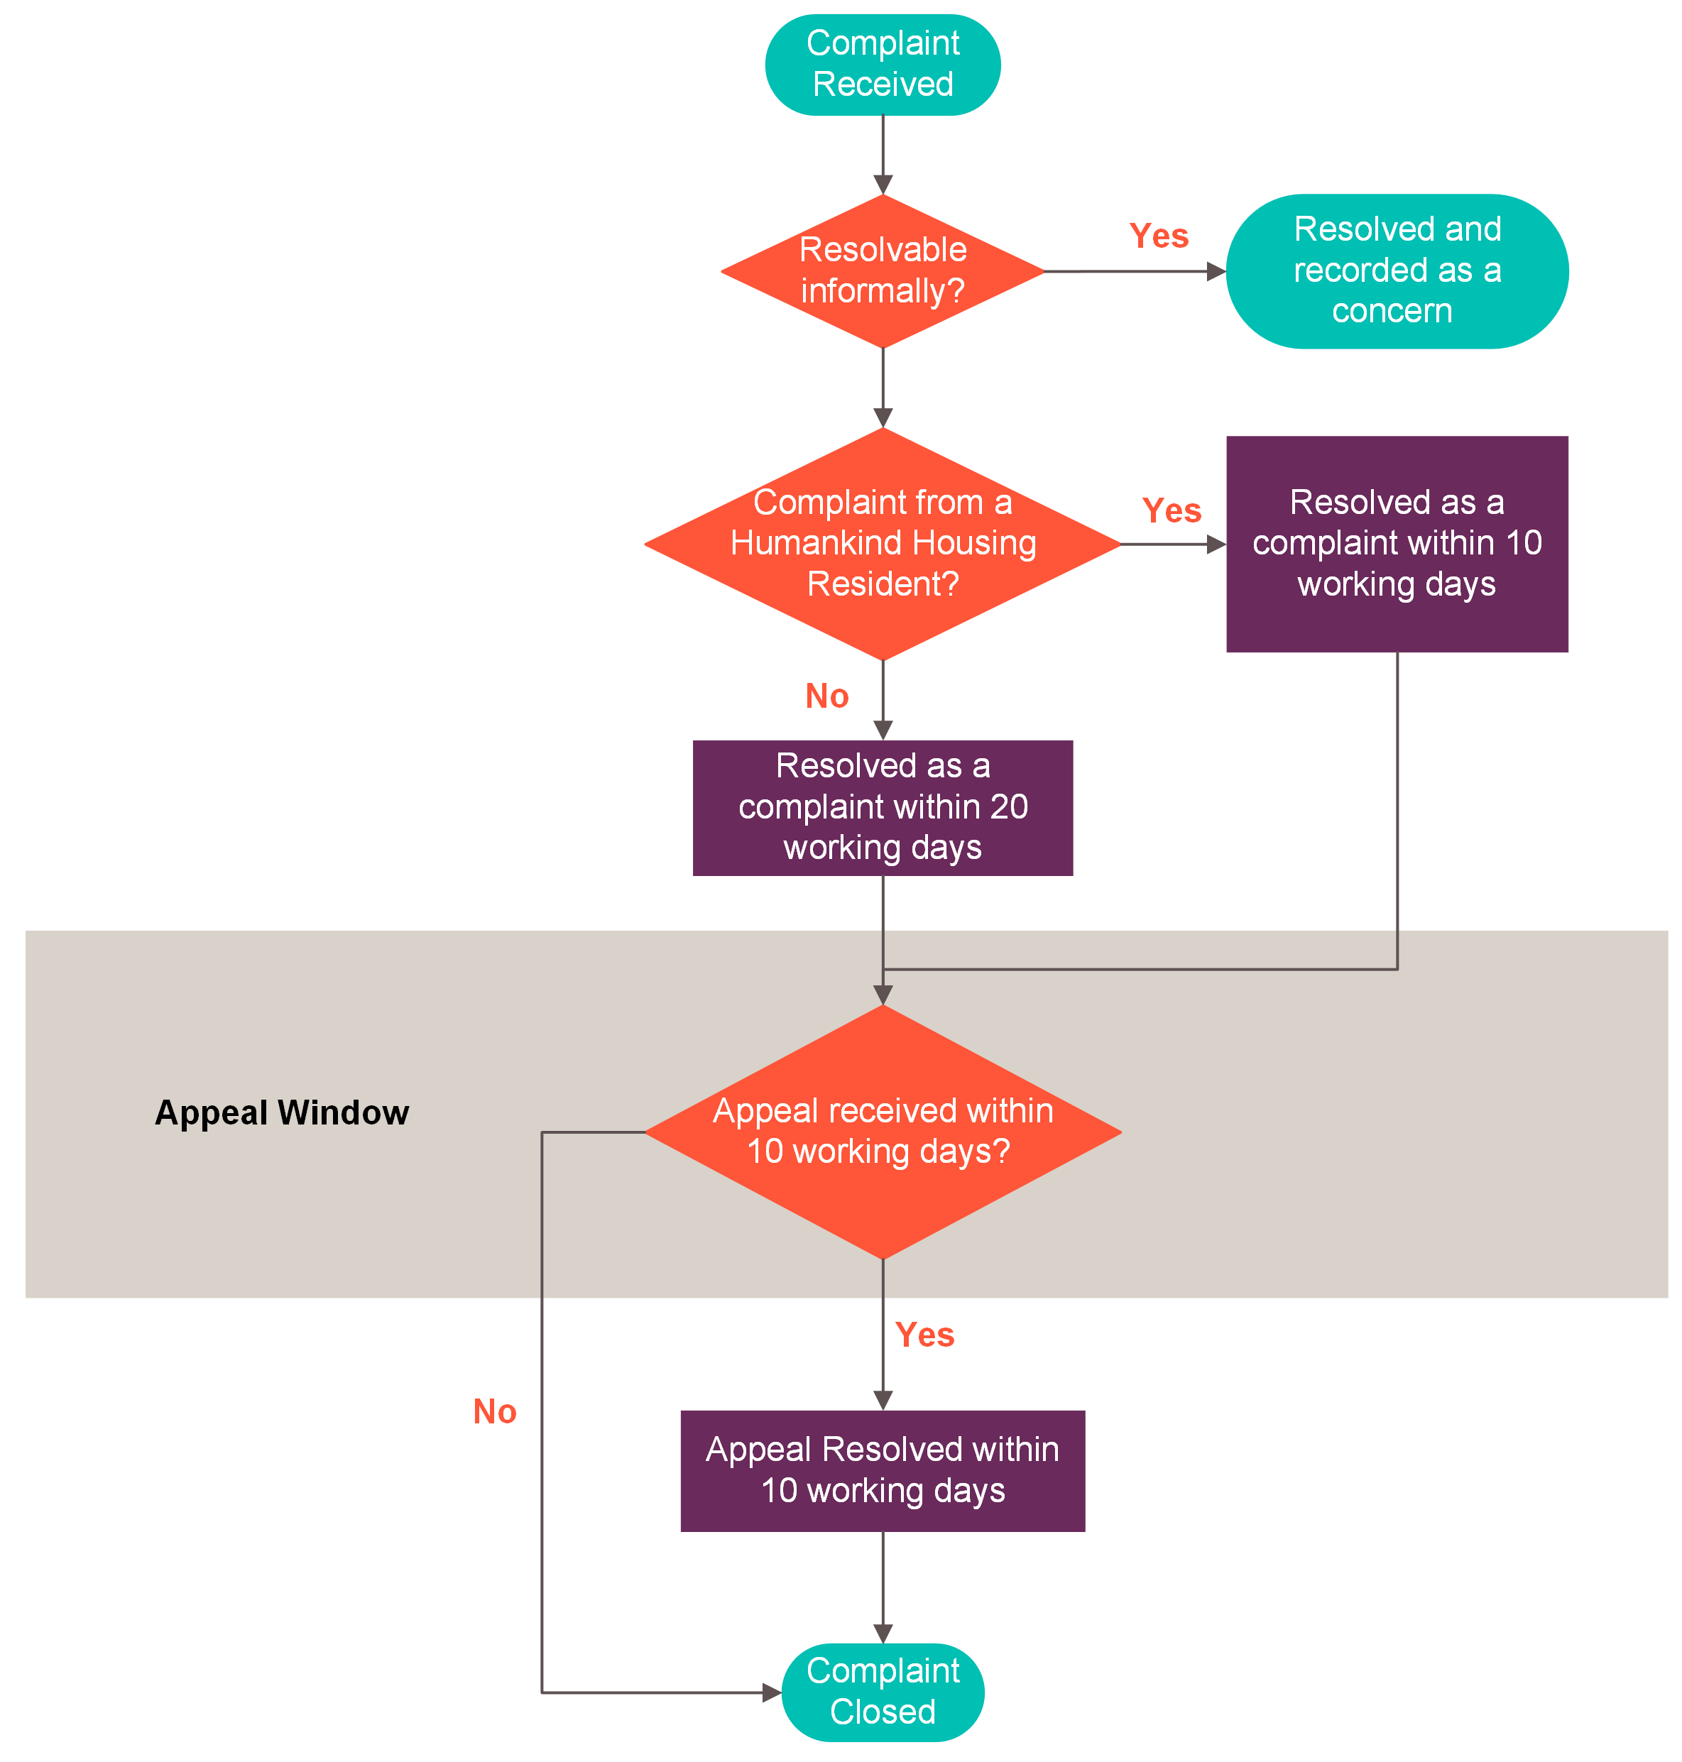

Appendix 4: Complaints and Appeal Handling Process 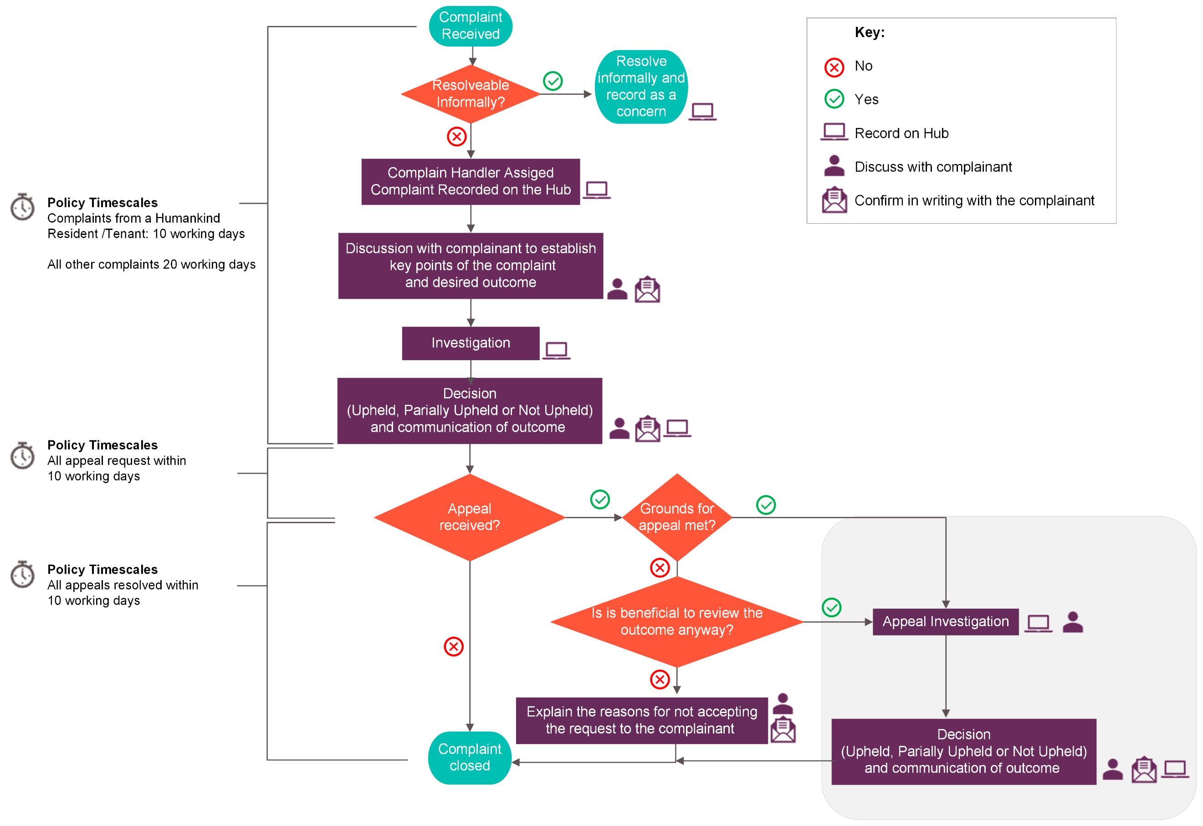
If Complaint relates to Spectrum or Changing Lives complaint also to be recorded on Ulysses (Spectrum) or Datix (Changing Lives)

Appendix 5: Complaint Handler Checklist

Within 24 hours | - Record on the HUB
Within 3 working  days | - Contact complainant:  - Thank the person for bringing the issue to North Yorkshire Horzions attention and assure them that the service they receive will not be negatively affected by letting us know about this issue  - Identify if they need additional support through the complaints process  - Listen to and record their concerns and confirm the key points  - Ask what resolution they would like (apology, training for staff, change in policy/processes, other)  - Agree preferred method of contacts/updates  - Confirm timescales for investigation and outcome  - Update the HUB with any additional information and clarify key points of the complaint  - Changing Lives to ensure Datixx is updated in line with the Changing Lives Policy  - Spectrum to ensure Ulysses is updated in line with the Spectrum Policy,
Without delay | Complaints indicating gross misconduct:  - Advise People Team Advisor/Business Partner  Where a disciplinary investigation is to be completed:  - Separate Investigation Manager allocated (for HR and Director to identify)  - Agree timing of both investigations and how information will be shared between them
Within 20 working days  Or  Complaints from Humankind Residents within 10 working days | Complaint Investigation  - Complete the Investigation  - Speak to witnesses  - Review documentation  - Review other evidence eg CCTV  - Complete the complaint investigation form on the HUB

Complaint Outcome
- Make a decision to uphold, partially uphold or not uphold each of the key points of the complaint and record on the Complaint Investigation Form

- Decide an outcome for the overall complaint (upheld, partially upheld or not upheld) and record on the Complaint Investigation Form
- Identify and record learning

- Notify:
  - Complainant
  - Staff involved in the complaint and the line manager
  - People Team Advisor/Business Partner (if relevant)
  - CEO if applicable (only for complaints received by the CEO or serious complaints)
Without delay | External Notifications  Agree with Director which, if any external organisations need to be notified, eg  - Local Authority Designated Officer (LADO)  - Police  - Care Quality Commission  - Charity Commission  - Information Commissioners Office  - Professional Registration bodies  - Commissioner / Funder

Appendix 6: Guidance for Complaint Handlers: Effective Complaint Handling Strategies

Effective complaint handling can:
- help to diffuse feelings of upset and frustration
- restore confidence in the organisation/service
- identify good practice in the service
- identify areas for development

Effective complaint handling looks like:
- Responding promptly - delays and poor communication can lead to frustration and a lack of faith in the process. Keep the complainant and other parties informed of any delays.
- Treating people with respect – people’s experience of the complaint handling process is just as important as the outcome of the complaint. We can demonstrate this by:
  - taking time to introduce yourself, and giving the person your contact details
  - speaking or meeting with them in person
  - showing empathy and showing you understand why they are dissatisfied or upset
  - giving the person the time and space to explain their concerns
  - using active listening skills, and summarising what they’ve told you to show you’ve understood
  - giving the person an opportunity to discuss or comment on your findings before you close the complaint
- Using appropriate language, avoiding jargon and acronyms
- Managing expectations by:
  - ensuring the person understands the your role and the complaint process from the outset
  - explaining how you will be dealing with the complaint
  - what issues you will be considering
  - their likely involvement
  - expected timeframes
  - possible outcomes of the complaint
- People are less likely to to retain information when they are upset; so it important to check understanding and provide the information in writing.
- Active listening
- Not avoiding difficult conversations. It’s natural to feel anxious about giving bad news or asking difficult questions, but it is important to be honest with complainants and other interested parties.

Some types of disability, neurodiversity or mental illness are associated with behaviours that can be challenging for complaint handlers. North Yorkshire Horizons will ensure that reasonable adjustments are made to accommodate an individual’s needs. Complainants will be offered support to complain. All complaints will be handled in line with North Yorkshire Horizons Equality and Diversity policies and with due regard to the Equality Act 2010.

Responding to challenging situations
Most challenging situations can be defused by using good complaint handling strategies. However, challenging situations may need additional strategies.

Additional strategies
Say No

- Ask the person to stop calling or visiting

- Set time limits for telephone calls and visits

- Ensure that the person is always direted back to the complaint handler or the complaint handler’s manager

Managing Engagement

- Being bombarding you with calls, visits or information when not warranted
- Different people being contacted seeking a different answer
- A refusal to accept the decision after the complaint has been investigated, the outcome explained, questions answered and the appeal process exhausted
Persistance

- An insistence on an immediate response or priority that is not warranted
- A demand for information that is not necessary eg staff contact details
- An insistence that the CEO or other member of the SMT, handle the complaint when that is not warranted
- Demands about how the complaint is to be investigated
- Demands that specific disciplinary actions are taken
Set limits

- Explain how you will be dealing with the complaint
- Tell the person that the demand will not met and why
- Explain the North Yorksahire Horizons Complaint Policy requires an appropriate manager to investigate. Reasure the person that you have sufficient knowledge of the service to be able to investigate thoroughly and appropriate authority to take any remdial action if needed. If they are dissatisfied with the outcome of the investigation, they can request an appeal which will be escalated to a more senior staff member.
Zero Tolerance

- Verbal abuse
- Aggressive behaviour
- Harassment
- Making threats

Set limits and conditions
- Name the behaviour and ask the person to stop
- Provide a warning. Offer a choice if possible
- Consider if the complaint handler needs to be changed

Appendix 7: Alternative Complaint Options
Complainants should be informed of any alternative complaint options available to them when we receive their complaint. When we inform a complainant of the outcome of an appeal, they should also be signposted to an appropriate alternative agency. Services are responsible for identifying the relevant alternatives complaint options, such as Ombudsman or service commissioners.
Examples of Alternative Complaint Options and wording to use in correspondence, is listed below. This list is not exhaustive, and Complaint Handlers should ensure they are aware all of the relevant alternative complaint options for their service.

CQC Registered Services
Example text to be included in complaints to services that are registered with CQC:

[Service Name] is registered with and regulated by the Care Quality Commission (CQC). The CQC cannot investigate individual complaints about providers, but is happy to receive information about services at any time.
You can contact the CQC at:
Care Quality Commission National Correspondence
Citygate
Gallowgate
Newcastle upon Tyne
NE1 4PA
Tel: 03000 616161
Web site: https://www.cqc.org.uk/contact-us

Complaints about how we’ve handled personal information
If someone is unhappy with how North Yorkshire Horizons has dealt with their personal data, they can complain to the Information Commissioner’s Office (ICO), which is an independent authority for data privacy. The ICO will review the complaint and in most instances share this with North Yokshire Horizons, asking us to respond directly to the Complainant. Complainants should be aware that it can take several months for North Yorkshire Horizons to receive their complaint letter from the ICO. By complaining directly to North Yorkshire Horizons we are able to respond more quickly to their complaint, however they do have the right to take their complaint to the ICO at anytime.
Example text to be included in appeal outcome letters to people who have complained about how North Yorkshire Horizons has handled their information:
If you are unhappy with the outcome of this appeal, you can ask the Information Commissioner’s Office (ICO) to consider your concern. If you decide to contact the ICO, you should do so within 3 months of this letter.
The ICO is the UK's independent body set up to uphold information rights. If the ICO decides that an organisation has failed to comply with the law, it will provide advice and instruction to help them get it right in the future. You can contact the Information Commissioner’s Office between 9am and 5pm, Monday to Friday, by:
Telephone: 0303 123 1113 or
Live chat on their website: https://ico.org.uk/global/contact-us/live-chat/live-chat-individuals/

Receipt of complaint Letter Template

[INSERT your name]
[INSERT office address]

[INSERT Complainant’s name]
[INSERT Complainant’s address]
[INSERT Date]

Dear [INSERT name]

Your complaint [INSERT Ref]
Thank you for telling us about your complaint. I’m sorry to hear you are unhappy with the service you have received from us. Following our discussion, I understand your complaint is that [INSERT your understanding of the complaint, using a bulleted or numbered list if there is more than one point]. Please let me know if I have misunderstood your concerns.
I will investigate your complaint as a matter of urgency and will be in touch with a full response within 20 working days of the date of this letter.
Please do contact me again in the meantime if I can be of further assistance, my contact details are below.

Yours sincerely,

[INSERT Signature]
[INSERT Name]
[INSERT phone number]

Outcome of complaint Letter Template
[INSERT your name]
[INSERT office address]

[INSERT Complainant’s name]
[INSERT Complainant’s address]
[INSERT Date]

Dear [INSERT Name],

Re: Outcome of your complaint [INSERT ref]

I have completed my investigation into your complaint. My findings are that -
[INSERT the points of the complaint, and for each point state whether the point is Upheld, Partially Upheld or Not Upheld and the reason why]

Therefore, I have Upheld / Partially Upheld / Not Upheld your complaint. [Delete as applicable]
[INSERT apology for things that were upheld / partially upheld if appropriate]

We have taken the following action in response to your complaint [INSERT the things done to address the complaint

Thank you once again for bringing your complaint to our attention. I hope you are satisfied with this outcome. However, I’ve included a form to complete and return within 10 working days if you are dissatisfied with outcome, and feel you have grounds for appeal.

Yours sincerely,

[INSERT Signature]
[INSERT Name]
[INSERT Phone number]

Appeal Letter Templates x2

[INSERT your name]
[INSERT office address]

[INSERT Complainant’s name]
[INSERT Complainant’s address]
[INSERT Date]

Dear [Name]
Re: Receipt of your Appeal [INSERT ref]

I write to confirm receipt of your appeal on the grounds that -
[INSERT the complainant’s grounds for appeal]

I will look into your appeal as a matter of urgency and notify you of the outcome within 10 working days.

Yours Faithfully,

[INSERT Name]
[INSERT Signature]

[INSERT your name]
[INSERT office address]

[INSERT Complainant’s address]
[INSERT Date]

Dear [INSERT Complainant title (Mr / Mrs / Miss etc) and Complainant Name] ,

Re: Outcome of your Appeal [INSERT ref]
I write to notify you of the outcome of your appeal.
[INSERT the following, depending on the grounds for appeal]

I have reviewed the original investigation and found that the investigation met our expectations
I have reviewed the original investigation and found that the investigation should have considered [INSERT]. I have now considered this information, and following this have decided

Therefore your complaint is upheld on appeal / partially upheld on appeal / not upheld

I have considered the additional information you provided. Given this new information I have decided to uphold your complaint on appeal / partially uphold you complaint on appeal [INSERT why]
I have considered the additional information you provided. Despite this new information I have decided to uphold your complaint on appeal / partially uphold you complaint on appeal [INSERT why ]

[INSERT apology if appropriate]
We will take the following action following this appeal
[INSERT action to be taken if appropriate]
[If not upheld provide information for complainant to raise concerns externally]

Yours Faithfully,
[INSERT Name]
[INSERT Signature]

Complaint Record Form & Appeal Form

